Lab 3: Creating a Custom Spatial Reference System (Fishnets & Toothpicks!)

Most of the time, we can use standard projection systems such as UTM or State Plane to represent spatial data. These work great for areas that fit within certain bounds. If we are working globally and/or regionally we have to use geographic data or a projection that will have large distortion issues. If we want to work at a scale that is between global and those provided by standard projection systems, we need to create a custom spatial reference system.

Goals
- Create a custom Spatial Reference System (SRS)
- Analyze the spatial error associated with a Spatial Reference System
- Also, use some new tools in ArcToolbox and install and use a custom tool
________________________________________________________________________
In this lab, you’ll create a custom SRS for an area you define and then analyze and report on the uncertainty in that region.

We have excellent datums in WGS84 and HARN and some federal agencies and a few industries still use NAD 83 or NAD27. This means there is really no need to create a new datum, so the process of defining a custom SRS is really about selecting a projection method, setting the parameters for the projection, and evaluating the uncertainty introduced by the projection.

1. Create an “Extent” shapefile to create an Area of Interest “AOI”

Since the Albers Equal-Area projection creates a projection with exact areas, we can use it to evaluate the area distortion of our SRS.

- Open a new Map Document (.MXD)
- Double-click on “Layers” within the table of contents to open up the Data Frame Properties dialog box, and select the “Coordinate System” tab.
- Set the projection to NAD 1927 California (Teale) Albers (Meters). HINT: it’s listed under Projected->State Systems.
- Add some ancillary data such as Aerial Imagery or a DEM for the western United States. I recommend doing this for each new MXD that you open up because it acts as a helpful reference.
- In ArcCatalog, create a new polygon shapefile named “lab3_extent”, and set the projection to “NAD 1927 California (Teale) Albers (Meters)” as well.
- Add it to your MXD and create a rectangle that is at least 1,000 km x 1,000 km. Make sure that the rectangle covers both portions of California and Oregon (WA, too, if you like).
- In the “Drawing” menu, select “Convert Graphics to Features…” and create a new shapefile with the graphic. This is an easy way to create shapefiles for reference in other work.
- Record the extent of your bounding rectangle (available in properties). You will be suing this data in the next few steps!
- You can find the bounds by simply moving the mouse cursor over your map and recording the values in the status bar.
- Find the center of your area by finding the mean latitude and longitude using the equations below. This will become the “origin” of your new SRS.

CenterLatitude=(East+West)/2
CenterLongitude=(North+South)/2

2. Create a “fishnet” shapefile to evaluate differences between various SRS

To create a “fishnet” shapefile covering the AOI, you will need to use the bounds from the previous step. The fishnet is more like a grid of parallelograms at right angles to one another than a traditional fishnet. The word “grid” is often used to describe this, but creates confusion with the concept of GRIDs in GIS.

- Find the fishnet tool in ArcToolbox. Use it to create a grid of polygons with at least 100x100 polygons.
- When entering your data in the “Create Fishnet” dialog box, use the screenshot below as a reference.
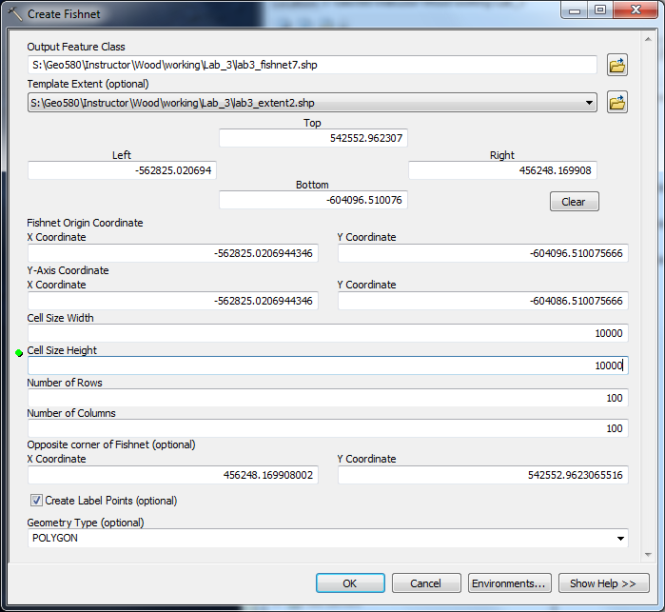

- Make the extent so that it approximates the previous example’s northing, easting, southing, westing, etc., but take care to make your fishnet file’s extent slightly smaller than your extent shapefile (i.e. the fishnet should fit within the extent rectangle). Enter 0 in the “Cell Size Width” and “Cell Size Height” fields and then enter 100 under both “Number of rows” and “Number of columns”. This will compute the cell dimensions for you to create a fishnet that contains 100 by 100 polygons.
- Choose POLYGON under the “Geometry Type” dropdown menu and click “OK” to create the fishnet.
- Add a field in the attribute table called “Area_CA_Albers” and compute the area for all the polygons by clicking “Calculate Geometry”.
- Save your MXD with an appropriate name and close it.

3. Create a custom SRS

To create a custom SRS, you’ll need to select a datum (really a GCS), select a projection method, and select the parameters for the projection method. There are a number of references for selecting the best projection methods listed at the end of this document. Create a method that will represent your area interest well and minimize the type of distortion that is most important for your study. For this step, I recommend creating an SRS in the Pacific Northwest & California region.

- Open up a new MXD.
- Go to the “Coordinate System” tab in the “Layers” Properties dialog and make sure that there is not a Coordinate System selected/activated.
- Click on the down arrow next the little globe, drag to “New” and select “Projected Coordinate System…”
- Name your projected coordinate system something with the name of your area of interest and the selected projection method in it (an example would be PNW_Albers_Custom for the Pacific Northwest Albers, or CA_Albers_Custom for California)
- Use the screenshots below as reference, BUT DO NOT COPY THE NUMBERS DIRECTLY – YOU SHOULD BE USING YOUR OWN NUMBERS!
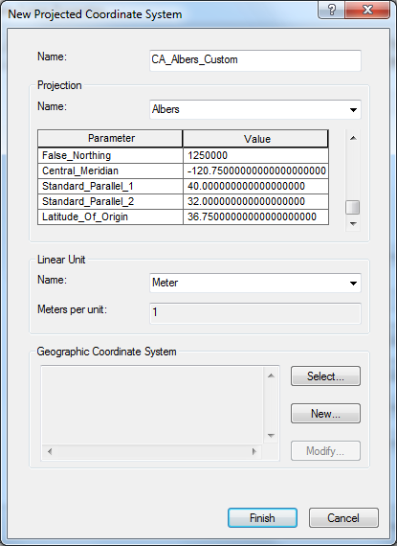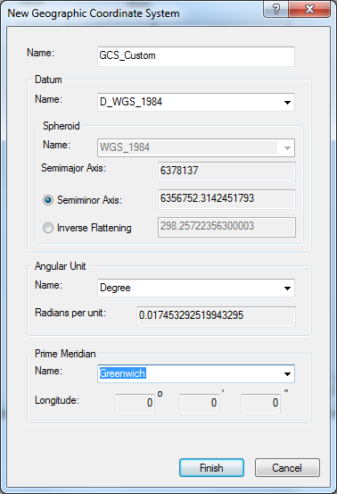

- Set the parameters as follows (use the data from Step #1 for this exercise):
  - Central_Meridan: The longitude of the center of your area
  - Latitude_Of_Origin: The latitude of the center of your area
  - False_Easting: the approximate width of your extent shapefile (in Meters)
  - False_Northing: the approximate height of your extent shapefile (in Meters)
- Depending on the projection selected, there may be other settings. You can research these with the resources at the end of this lab. For Albers use the following:
  - Standard_Parallel_1: A latitude that is toward the top of your area, but not outside the bounds of your extent!
  - Standard_Parallel_2: A latitude that is toward the bottom of your area, but not outside the bounds of your extent!
- Under Geographic Coordinate System, click “Change”. Select your desired datum or click on the little globe to create a “New” one (not really recommended as we have enough datums!). I recommend WGS84 for just about all natural resource work.
- Make sure you add your new spatial reference as a favorite or it will disappear.

4. Calculate the area

- Add your fishnet shapefile to the current MXD, and create a field in the attribute table called “Area_CA_Albers_Custom” or “Area_PNW_Albers_Custom”. Field names have a text length limitation, so choose a short enough name that is descriptive without being too cryptic. Calculate Geometry for the newly added field.
- Add another attribute and divide the area calculation by the AlbersArea. The results that are near 1 represent minimal area distortion. Larger values indicate that your projection has made the areas larger while smaller values indicate your projection made the areas smaller.
- Use symbology to display the layer based on the area distortion.
- Save your MXD with an appropriate name and close it.

5. Evaluate Distance Distortion

In this section, you’ll install a custom tool and then use it to create a Shapefile with “toothpicks” or lots of one-segment polylines. Then, you’ll use the toothpicks to compute the distortion due to distance.

- Install the “Create Toothpicks” tool provided with this lab.
- You can install a new tool by simply placing it in a folder on your computer that ArcGIS can access. In this case, your personal folder on the (U:) drive will work just fine. Note that the Python script and the toolbox file (“.tbx”) must be in the same folder.
- Open up a new MXD, and open up ArcToolbox to add the tool. See the screenshot below.
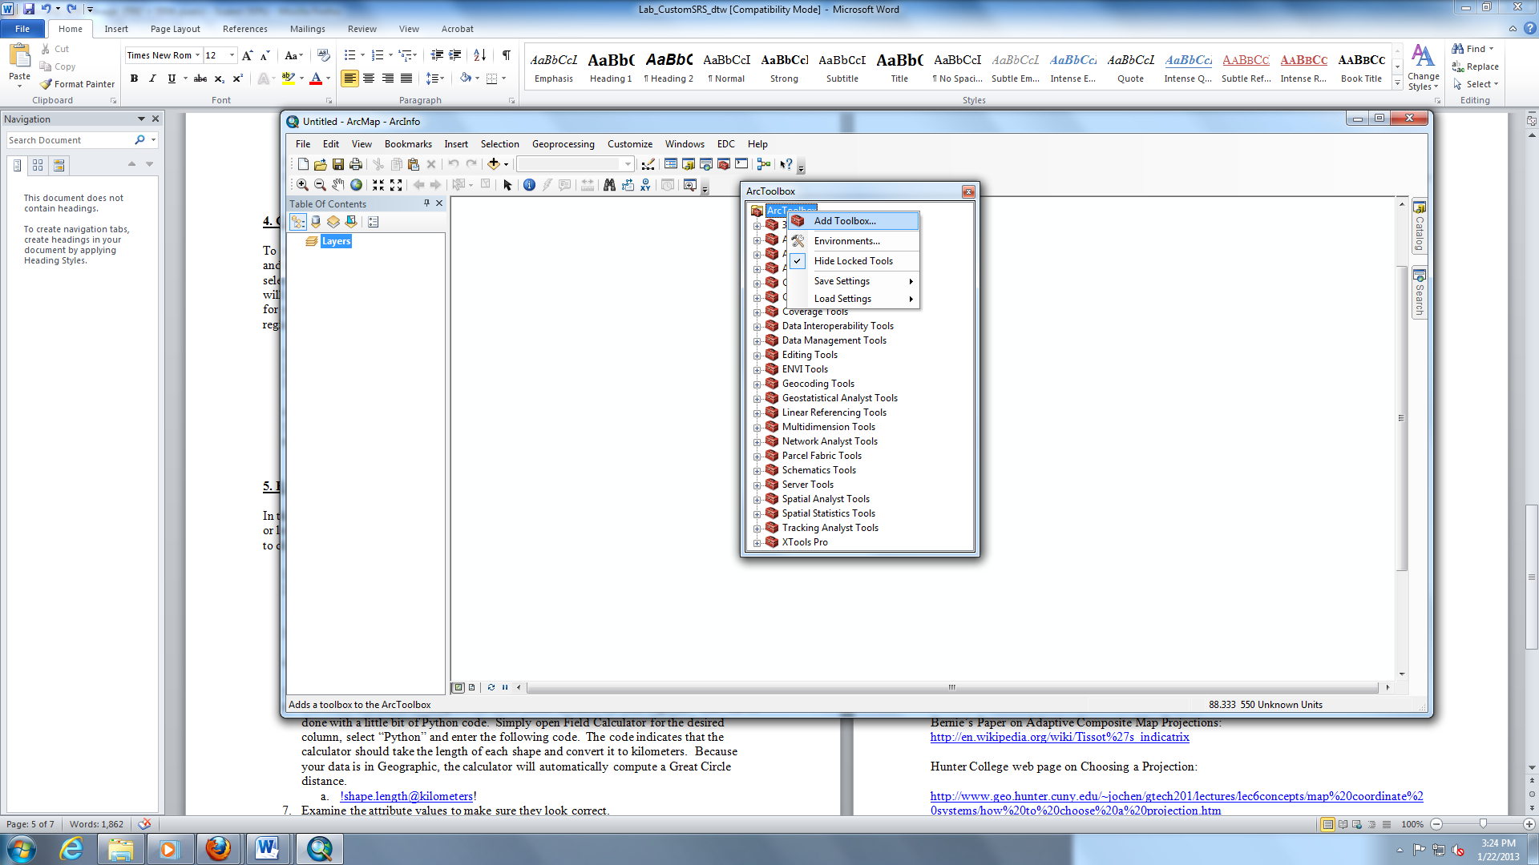
- Once you’ve added the “Create Toothpicks Tool”, right click on the python script under “Geo580” and select “Properties”. Make sure that the pathname listed under source refers to the correct location of the script.
- Use the “Create Toothpicks” tool create a grid of over your area of interest in Geographic projection. Use the bounding Latitudes and Longitudes that you recorded in the previous step to set the bounds. Make sure you make a grid of at least 100x100 toothpicks. Make sure you navigate to an appropriate file location and type in the name for your new shapefile. Use this screenshot as an example (BUT DON’T COPY VERBATIM):
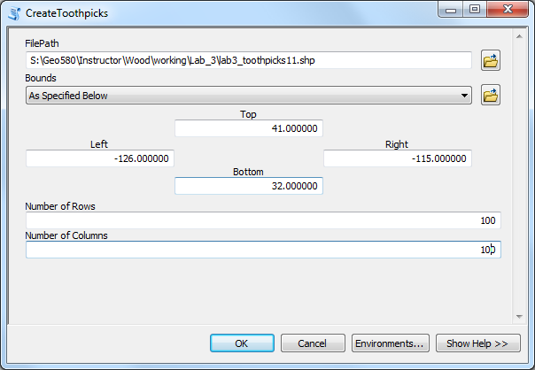
- Add an attribute to the new Shapefile with type of double. Name it “Great_Circle”.
- Use Field Calculator to compute the Great Circle distance for each segment. This can be done with a little bit of Python code. Simply open Field Calculator for the desired column, select “Python” and enter the following code. The code indicates that the calculator should take the length of each shape and convert it to kilometers. Because your data is in Geographic, the calculator will automatically compute a Great Circle distance. Be sure to select all of the records in your shapefile before running this script.
  - !shape.length@kilometers!
- Examine the attribute values to make sure they look correct.
- Open up your “custom” MXD (the one in which you created a custom Albers SRS), and add your toothpick shapefile. Add attribute field named “Length_CUSTOM” (or something like that).
- Using “Calculate Geometry”, calculate the length of each record within the shapefile. Be sure to select “kilometers” from the drop-down menu, and also be sure to click the radio button next to “Use coordinate system of the data frame” (which should be your custom SRS).
- Compute the distortion by dividing the linear distance by the distance from the geography

6. Finding the Optimal SRS

There is no tool for finding the optimal SRS but you can use trial and error with the process above to find an SRS close to optimal. You can now try different projection methods and projection parameters, evaluate their distortions, and select the one you want for your area of interest.

Questions (use the answers to these questions as guidelines for your Final Turn In – see below):

- What is the difference between the polar and equatorial radius of the earth as defined by WGS84?
- Why are the distance in the toothpicks file the same for the vertical (lines of longitude) but different for horizontal (lines of latitude) line segments?
- How do you feel about your area distortion given your project requirements?
- How do you feel about your distance distortion given your project requirements?

Resources

Jim’s page on selecting projections:
https://dl.dropbox.com/u/37858409/JimsProfessional/Resources/SelectingAProjection.html

Flex Projector for selecting projections:
http://flexprojector.com/

Geocart for investigating various projections:
http://www.mapthematics.com

USGS Web Page on Map Projections: http://egsc.usgs.gov/isb//pubs/MapProjections/projections.html

Wikipage on projections: http://en.wikipedia.org/wiki/Map_projection

Wikipage on Tissot’s indicatrix: http://en.wikipedia.org/wiki/Tissot%27s_indicatrix

Bernie’s Paper on Adaptive Composite Map Projections: http://en.wikipedia.org/wiki/Tissot%27s_indicatrix

Hunter College web page on Choosing a Projection:

http://www.geo.hunter.cuny.edu/~jochen/gtech201/lectures/lec6concepts/map%20coordinate%20systems/how%20to%20choose%20a%20projection.htm

FINAL TURN IN:

- A short report on your selected spatial reference system. This should include the values for the SRS, an area of interest map, at least one image of area distortion, and one of distance distortion. Also include answers to the questions.

Extra Credit:

- Evaluate conformal (angular or shape) distortion for at least one of your custom SRSes.

