Land Use in Humboldt County

By: Jim Graham

13th of September, 2013

# Abstract

Land use in Humboldt County, in the northwestern corner of California, contains the following land use types: 57% timber, 25% open, 4% tribal, 2% agricultural and 1% other uses.

# Introduction

Humboldt County is one of the most northerly counties in California and is bordered by the Pacific Ocean and the Klamath Mountain Range (Figure 1). The county is rich in history, agriculture, industry, and educational institutions. The Humboldt County Planning Commissions General Plan outlines the land use practices for each parcel within the county (Planning Commission, 2008).

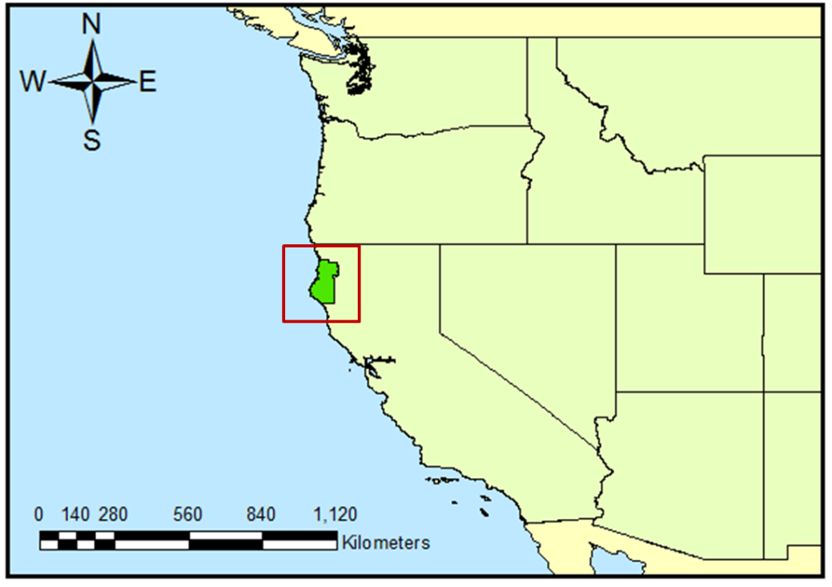

Figure 1. Map showing the location of Humboldt County within California.

# Methods

County boundary and land use data sets were downloaded from the Humboldt County web site. Additional background layers for states and countries were obtained from the National Atlas web site ([www.nationalatlas.gov](http://www.nationalatlas.gov)) and the Natural Earth web site (www.naturalearthdata.com).

Qualification of the data, calculations, and preparation of the maps were performed in ArcMap version 10.1 (Esri, Inc.). Additional calculations were performed in Microsoft Excel 2010. The GNU Image Manipulation Program (GIMP) version 2.8 ([www.gimp.org](http://www.gimp.org)) and Microsoft PowerPoint 2010 were used for preparation of the final maps.

All data was first checked to see if it was properly georeferenced using 24,000 scale digital raster graphics from TopoQuest ([www.topoquest.com](http://www.topoquest.com)). Then, all data was projected into World Geodetic System 1984 (WGS 84) datum and the University Transverse Mercator, Zone 10 North, projection. Calculations were based on the existing entries in the attribute tables. I added this sentence to have an example of referencing a book (Marris, 1982). Here is a sentence that shows a citation for an article (Minica, 2007).

# Results

Land use in Humboldt County is dominated by timber at over 57%, followed by open lands at 25%, and Tribal lands at 4%. Agriculture makes up just over 2% and all other categories of land use are below 1% (Table 1).

Table 1. Summary of land use within Humboldt County

|  |  |  |  |
| --- | --- | --- | --- |
| **Land Use Type** | **Number of Parcels** | **Number of Acres** | **Percent of the Total** |
| Agriculture | 196 | 2713 | 2.1 |
| Religious | 1458 | 50046 | 0.01 |
| Urban | 103 | 400 | 0.7 |
| Industry | 22420 | 17333 | 0.09 |
| Open | 1191 | 1794 | 25 |
| Residential | 103 | 2094 | 5.0 |
| Timber | 3005 | 581221 | 57 |
| Commercial | 1077 | 14480 | 0.08 |
| Public | 23165 | 115593 | 0.6 |
| Tribal | 8026 | 1312892 | 4.0 |

Timber land is spread throughout Humboldt County with tribal and open space dominating only in the northeast corner of the county (Figure 2).

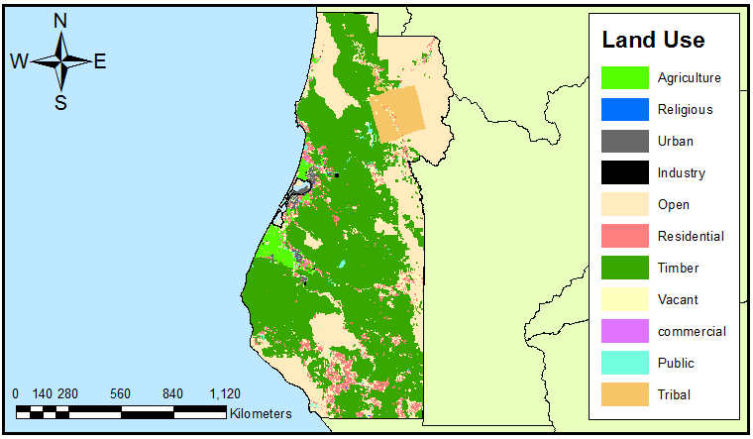

Figure 2. Land use within Humboldt County

# Conclusion

This report shows that Humboldt County is dominated by timber and open lands. This confirms the counties reputation for large, productive, and beautiful forests.

This short report is provided as an example of how to represent spatial information in a document created with Microsoft Word. The land use types are from the Humboldt County web site and are estimates of the actual land use practices. Thus, the results presented here will include uncertainty associated with these estimates. Additional work could further refine these estimates by including more detailed data.

# Acknowledgements

Data for this study were provided by the Humboldt County GIS Department, Natural Earth, and the National Atlas. Funding, computer access and other facilities were provided by Humboldt State University.

## Bibliography

Planning Commission, “Humboldt 21st Century: General Plan”, Humboldt County Website, Humboldt County Planning Division, March 13th, 2008, < http://co.humboldt.ca.us/gpu/documentsplan.aspx>

Marris, P, 1982, Community planning and conceptions of change, Routledge & Kegan Paul, ISBN 0710093497.

Minca, C., 2007, Humboldt's Compromise, or the Forgotten Geographies of Landscape, Progress in Human Geography, Volume 31, Issue 2, Pages 179-193.