Key

Questions (3): 4 each (12 points)

Maps showing potential impact of at least two seal level rises: 30 points

Table with impacts: 30 points

Remainder of report: 20 points

Question 1: List the "Pixel Type," "Pixel Depth," and "Cell Size" for the DEM.

- Pixel Type: floating point

- Pixel Depth: 32 Bit

- Cell Size: 8.9640954, 8.9640954

Question 2: How much land appears to be between 0 and 1 meters? You may need to zoom in and toggle between the two layers to see the pixels that are between 0 and 1.

- Very small number of pixels around the edge

Question 3: Zoom in to an area of Arcata and examine the differences between the raster and polygon version of the parcel layers. What impact do you think this difference will have on the analysis?

- Required: Changes results by unknown amount

- Extra: changes will be “averaged out”

Question 4: What "Pixel Type" is the new raster?

- Unsigned integer

Below is the table of various values. The two main problems are from suing a different pixel width (the image is 8. 964 x 8. 964 but some students will use 9 or 10). The bigger problem is from miss-classifying the attributes. -1 for each answer that is off by more than 10%.

|  |  |  |  |  |
| --- | --- | --- | --- | --- |
|  | 1 Meter | 2 Meter | 5 Meter | 10 Meter |
| Value | Count | Count | Count | Count |
| 0.0 | 21,991,082.0 | 21,417,758.0 | 20,302,078.0 | 19,550,571.0 |
| Hectares assuming 8. 964 x 8. 964meter pixels | | | | |
|  | 176693 | 172091 | 163104 | 157062 |
| City | 35 | 590 | 1471 | 1964 |
| Agricultural | 21 | 2837 | 9468 | 13241 |
| Residential | 3.2 | 25 | 290 | 841 |
| Commercial | 0.17 | 4.8 | 37 | 57 |
| Industrial | 6.0 | 79 | 253 | 559 |
| Recreational | 50 | 1116 | 1822 | 2352 |
| Tribal | 0.072 | 0.23 | 0.69 | 1.4 |
| Public | 3.7 | 60 | 292 | 540 |
| Other | 0.83 | 9.0 | 74 | 193 |

Inundation for 1 meter sea level rise (notice tiny green points):



Map with 2, 5, and 10 meter sea level rise scenarios

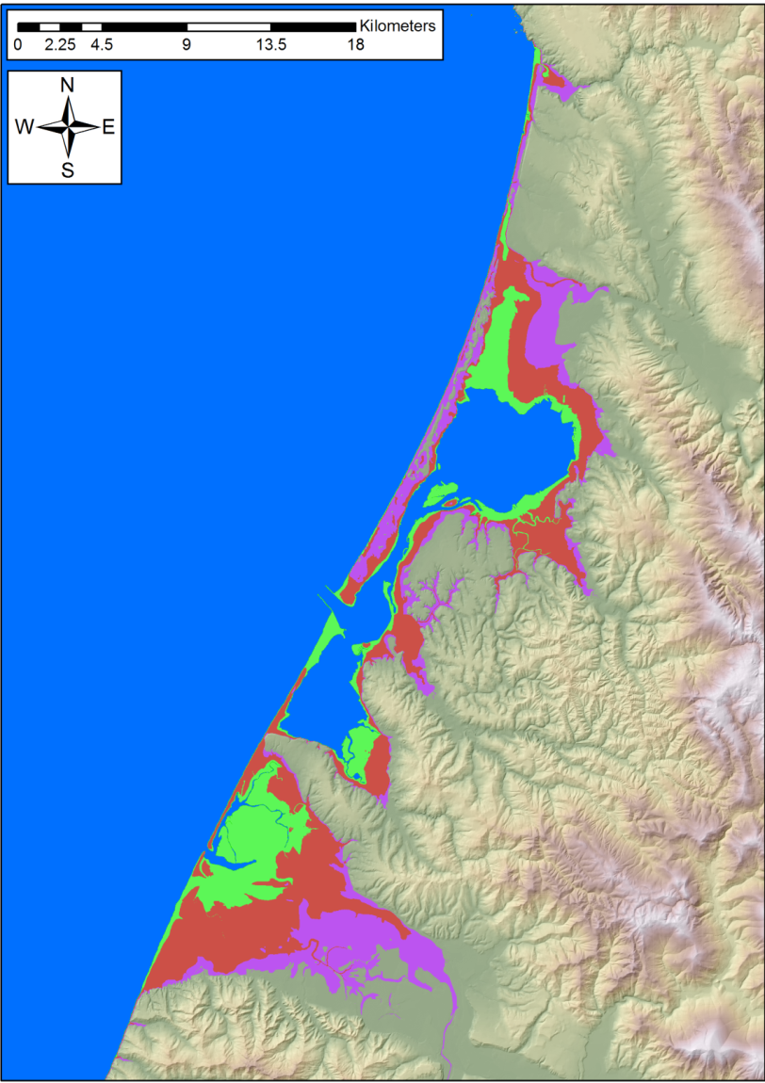

**Appendix – Other answers**

|  |  |  |  |  |
| --- | --- | --- | --- | --- |
|  | 1 Meter | 2 Meter | 5 Meter | 10 Meter |
| Value | Count | Count | Count | Count |
| 0.0 | 21,991,082.0 | 21,417,758.0 | 20,302,078.0 | 19,550,571.0 |
| City | 4,312.0 | 74,366.0 | 184,786.0 | 246,717.0 |
| Agricultural | 2,573.0 | 353,142.0 | 1,177,529.0 | 1,646,911.0 |
| Residential | 394.0 | 3,072.0 | 36,072.0 | 104,699.0 |
| Commercial | 21.0 | 593.0 | 4,663.0 | 7,119.0 |
| Industrial | 748.0 | 9,783.0 | 31,482.0 | 69,573.0 |
| Recreational | 6,255.0 | 138,946.0 | 226,827.0 | 292,744.0 |
| Tribal | 9.0 | 29.0 | 86.0 | 177.0 |
| Public | 462.0 | 7,443.0 | 36,306.0 | 67,218.0 |
| Other | 15.0 | 739.0 | 6,042.0 | 20,142.0 |
|  |  |  |  |  |
| Hectares assuming 10 x 10 meter pixels | | |  |  |
|  | 219,910.8 | 214,177.6 | 203,020.8 | 195,505.7 |
| City | 43.1 | 743.7 | 1,847.9 | 2,467.2 |
| Agricultural | 25.7 | 3,531.4 | 11,775.3 | 16,469.1 |
| Residential | 3.9 | 30.7 | 360.7 | 1,047.0 |
| Commercial | 0.2 | 5.9 | 46.6 | 71.2 |
| Industrial | 7.5 | 97.8 | 314.8 | 695.7 |
| Recreational | 62.6 | 1,389.5 | 2,268.3 | 2,927.4 |
| Tribal | 0.1 | 0.3 | 0.9 | 1.8 |
| Public | 4.6 | 74.4 | 363.1 | 672.2 |
| Other | 0.2 | 7.4 | 60.4 | 201.4 |
|  |  |  |  |  |
| Hectares assuming 8.9 x 8.9 meter pixels | | |  |  |
|  | 174,200.6 | 169,659.0 | 160,821.3 | 154,868.3 |
| City | 34.2 | 589.1 | 1,463.8 | 1,954.3 |
| Agricultural | 20.4 | 2,797.4 | 9,327.7 | 13,045.9 |
| Residential | 3.1 | 24.3 | 285.7 | 829.4 |
| Commercial | 0.2 | 4.7 | 36.9 | 56.4 |
| Industrial | 5.9 | 77.5 | 249.4 | 551.1 |
| Recreational | 49.5 | 1,100.6 | 1,796.8 | 2,318.9 |
| Tribal | 0.1 | 0.2 | 0.7 | 1.4 |
| Public | 3.7 | 59.0 | 287.6 | 532.5 |
| Other | 0.1 | 5.9 | 47.9 | 159.6 |
| Hectares assuming 8. 964 x 8. 964meter pixels | | | | |
|  | 176693.41038 | 172091.356095 | 163104.48982 | 157062.547465 |
| City | 34.63085 | 590.516255 | 1471.489725 | 1963.906665 |
| Agricultural | 20.67405500000 | 2837.49597 | 9467.81727 | 13241.34253 |
| Residential | 3.16579 | 24.68352 | 289.83852 | 841.256465 |
| Commercial | 0.168735 | 4.764755 | 37.467205 | 57.201165 |
| Industrial | 6.01018 | 78.606405 | 252.95787 | 559.019055 |
| Recreational | 50.258925 | 1116.43111 | 1822.554945 | 2352.19804 |
| Tribal | 0.072315 | 0.233015 | 0.69101 | 1.422195 |
| Public | 3.71217 | 59.804505 | 291.71871 | 540.57873 |
| Other | 0.83564 | 9.04741 | 73.913965 | 193.46673 |