**Key**

1. Map of potential site (there is only one in northern Arcata) and a view shed (40 points)

2. Questions (5 each for 30 points)

* Question 1: What is the resolution of the files?
  + 10 meters per pixel
* Question 2: What is the spatial reference associated with the files?
  + NAD 1927, UTM Zone 10 North
* Question 3: What is the "Pixel Type" and "Pixel Depth" for the files?
  + Floating point
  + 32-bit
* Question 4: Are there more flat areas or steep areas in and around Arcata?
  + mostly flat in Arcata with some steep slopes to the east
* Question 5: What are the steps you used to create the south-facing raster?
  + This could be one with one band in reclass or the following raster calculator equation:
    - (“Aspect.img” >135) & (“Aspect.img” < 225)
* Question 6: What type of terrain is visible to your site-centroid?
  + There are a number of ways to answer this but basically slopes facing the site and flat areas a ways from the site.

3. Remainder of the report (30 points)

**Extra Credit (10points)**

1. Map with contour lines

Potential site shown selected.

- Red – potential sites

- Blue – additional areas of slope greater than 1 and less than 5

- Green – additional areas of south-facing aspect

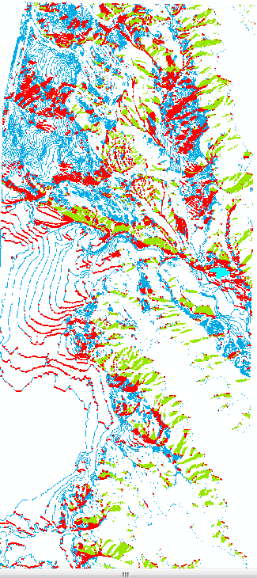

View shed (0 elevation)

View shed with 5 meter elevation: